**1. BUSINESS DESCRIPTION**

**1.1 Business Background**

Social Media Database is designed to support the core functionality of a social networking platform.  
It allows users to register, create profiles, share posts and media, communicate via messages, follow others, use hashtags, and receive notifications.  
The system aims to store all necessary user activities while maintaining data integrity and efficient access.

**1.2 Problems. Current Situation**

Without a centralized database, user-generated data (posts, comments, likes, etc.) become fragmented and hard to manage.  
Typical issues include:

* Redundant data about users and posts.
* Difficulty in linking media, hashtags, and user interactions.
* Low performance when retrieving large amounts of content.
* Complications in tracking user relationships and notifications.

**1.3 Benefits of Implementing a Database (Project Vision)**

The designed database will:

* Store structured information about users, posts, and interactions.
* Allow easy retrieval and filtering of content.
* Support scalability for millions of records.
* Ensure referential integrity and normalization up to the **3rd Normal Form (3NF)**.
* Support analytical features in the future (trending hashtags, user activity).

**2. MODEL DESCRIPTION**

**2.1 Definitions & Acronyms**

| **Acronym** | **Meaning** |
| --- | --- |
| PK | Primary Key |
| FK | Foreign Key |
| 1:N | One-to-Many relationship |
| M:N | Many-to-Many relationship |
| ENUM | Enumerated data type |
| ERD | Entity-Relationship Diagram |

**2.2 Logical Scheme**

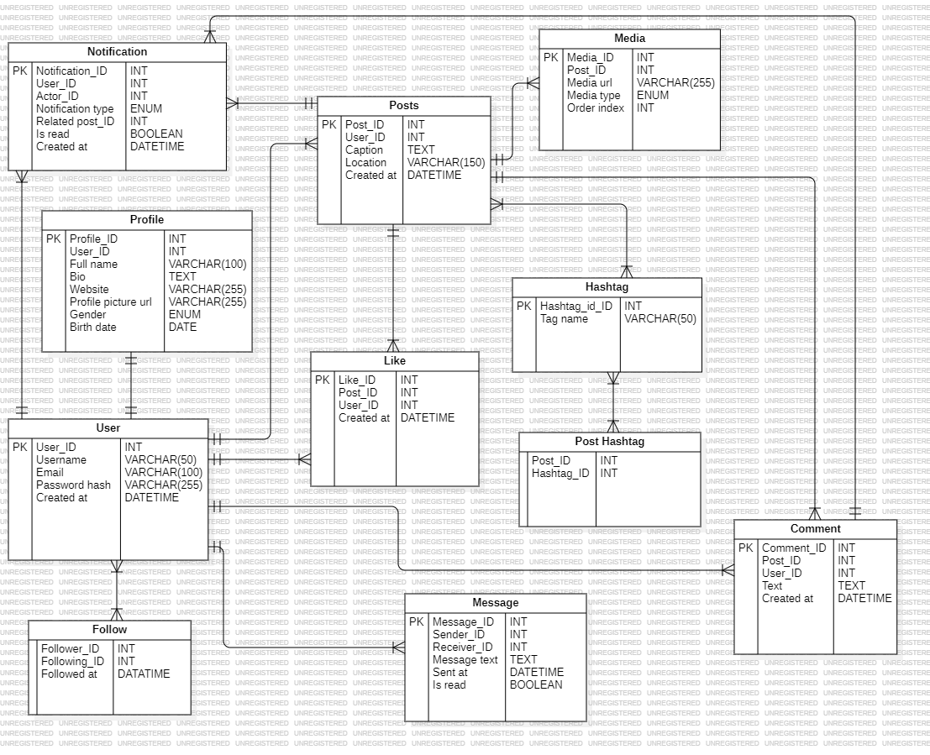

**2.3 Objects**

Below is a detailed table-by-table breakdown of entities and their fields.

**Table: User**

| **Field Name** | **Description** | **Data Type** |
| --- | --- | --- |
| **User_ID (PK)** | Unique user identifier | INT |
| **Username** | Unique username | VARCHAR(50) |
| **Email** | User’s email | VARCHAR(100) |
| **Password_hash** | Encrypted password | VARCHAR(255) |
| **Created_at** | Account creation date | DATETIME |

**Table: Profile**

| **Field Name** | **Description** | **Data Type** |
| --- | --- | --- |
| **Profile_ID (PK)** | Unique profile identifier | INT |
| **User_ID (FK)** | Link to User | INT |
| **Full_name** | Full name | VARCHAR(100) |
| **Bio** | User biography | TEXT |
| **Website** | Personal website | VARCHAR(255) |
| **Profile_picture_url** | Link to profile image | VARCHAR(255) |
| **Gender** | User gender | ENUM('male','female','other') |
| **Birth_date** | User’s birth date | DATE |

**Table: Posts**

| **Field Name** | **Description** | **Data Type** |
| --- | --- | --- |
| **Post_ID (PK)** | Unique post ID | INT |
| **User_ID (FK)** | Author of post | INT |
| **Caption** | Post text or caption | TEXT |
| **Location** | Optional location name | VARCHAR(150) |
| **Created_at** | Date and time of creation | DATETIME |

**Table: Comment**

| **Field Name** | **Description** | **Data Type** |
| --- | --- | --- |
| **Comment_ID (PK)** | Unique comment ID | INT |
| **Post_ID (FK)** | Related post | INT |
| **User_ID (FK)** | Author of comment | INT |
| **Text** | Comment text | TEXT |
| **Created_at** | Date and time | DATETIME |

**Table: Like**

| **Field Name** | **Description** | **Data Type** |
| --- | --- | --- |
| **Like_ID (PK)** | Like record ID | INT |
| **Post_ID (FK)** | Liked post | INT |
| **User_ID (FK)** | User who liked | INT |
| **Created_at** | Time of like | DATETIME |

*(This table resolves the M:N relationship between User and Posts.)*

**Table: Follow**

| **Field Name** | **Description** | **Data Type** |
| --- | --- | --- |
| **Follower_ID (FK)** | The user who follows | INT |
| **Following_ID (FK)** | The user being followed | INT |
| **Followed_at** | Date of follow | DATETIME |

*(Self-referential M:N relationship within the User table.)*

**Table: Message**

| **Field Name** | **Description** | **Data Type** |
| --- | --- | --- |
| **Message_ID (PK)** | Unique message ID | INT |
| **Sender_ID (FK)** | Message sender (User) | INT |
| **Receiver_ID (FK)** | Message receiver (User) | INT |
| **Message_text** | Content of message | TEXT |
| **Sent_at** | Time sent | DATETIME |
| **Is_read** | Message read status | BOOLEAN |

**Table: Notification**

| **Field Name** | **Description** | **Data Type** |
| --- | --- | --- |
| **Notification_ID (PK)** | Notification ID | INT |
| **User_ID (FK)** | Receiver of notification | INT |
| **Actor_ID (FK)** | Triggering user | INT |
| **Notification_type** | Type (like, comment, follow) | ENUM |
| **Related_post_ID** | Reference to post (optional) | INT |
| **Is_read** | Read status | BOOLEAN |
| **Created_at** | Time created | DATETIME |

**Table: Media**

| **Field Name** | **Description** | **Data Type** |
| --- | --- | --- |
| **Media_ID (PK)** | Unique media ID | INT |
| **Post_ID (FK)** | Related post | INT |
| **Media_url** | File path or URL | VARCHAR(255) |
| **Media_type** | ENUM('image','video') | ENUM |
| **Order_index** | Display order | INT |

**Table: Hashtag**

| **Field Name** | **Description** | **Data Type** |
| --- | --- | --- |
| **Hashtag_ID (PK)** | Unique hashtag ID | INT |
| **Tag_name** | Hashtag text | VARCHAR(50) |

**Table: Post_Hashtag**

| **Field Name** | **Description** | **Data Type** |
| --- | --- | --- |
| **Post_ID (FK)** | Related post | INT |
| **Hashtag_ID (FK)** | Related hashtag | INT |

*(This table resolves the M:N relationship between Posts and Hashtag.)*

**Comments on Relationships**

* **User ↔ Profile:** 1:1
* **User ↔ Posts:** 1:N
* **User ↔ Comment:** 1:N
* **User ↔ Message (Sender/Receiver):** 1:N (self-relationship)
* **User ↔ User (Follow):** M:N self-referential
* **User ↔ Posts (Like):** M:N via Like
* **Posts ↔ Media:** 1:N
* **Posts ↔ Comment:** 1:N
* **Posts ↔ Hashtag:** M:N via Post_Hashtag
* **User ↔ Notification:** 1:N
* **Comment (no recursion)** – can be extended later for replies

**Example with Data**

| **User_ID** | | **Username** | | **Email** | | **Created_at** | |
| --- | --- | --- | --- | --- | --- | --- | --- |
| 1 | | vita | | vita@gmail.com | | 2025-01-01 | |
| 2 | | max | | max@gmail.com | | 2025-02-03 | |
| **Post_ID** | **User_ID** | | **Caption** | | **Created_at** | |
| 1 | 1 | | "My first post!" | | 2025-01-02 | |
| 2 | 2 | | "Nice weather!" | | 2025-02-03 | |

| **Like_ID** | **Post_ID** | **User_ID** | **Created_at** |
| --- | --- | --- | --- |
| 1 | 1 | 2 | 2025-01-03 |
| 2 | 2 | 1 | 2025-02-04 |